Assignment 2: Dashboard
Team members: Hafsa Id Said, Noor Muhammad

Strategic Sales Performance Dashboard for Retail Management

Introduction
This project focuses on building a strategic sales performance dashboard for a retail company using the Superstore dataset. The main purpose of this project is to transform raw sales data into meaningful insights that can support better business decisions.
Instead of simply presenting numbers, the dashboard is designed to give managers a clear and structured overview of sales performance, profitability, and trends over time. It provides a single-screen summary that helps decision-makers quickly understand the current situation of the business and identify areas that require attention.

Business Context
The company operates in the retail industry and sells products across three main categories: Furniture, Office Supplies, and Technology. It serves different customer segments, including Consumer, Corporate, and Home Office customers, and operates across several regions.
Because the company works with different products, customer types, and regions, performance can vary significantly. Some categories may perform well in certain regions but poorly in others. For this reason, management needs a centralized dashboard to monitor overall performance and compare results across segments.

Business Problem
Although the company generates strong sales revenue, profitability is not stable across all product categories and regions. In some cases, products generate high sales but low profits due to high discount levels. In other cases, certain regions may even generate negative profits.
Currently, management does not have a clear, consolidated view of performance. Without a strategic dashboard, it becomes difficult to quickly identify:
- Which categories are underperforming
- Which regions generate low or negative profit
- Whether discount strategies are affecting profitability
- How sales evolve over time
This creates a need for a dashboard that allows management to monitor performance in a structured and visual way.

Business Objectives
The main objectives of this dashboard are:
- To monitor total sales and total profit
- To evaluate overall profitability using profit margin
- To identify underperforming products or regions
- To analyze sales trends over time
- To support data-driven decision-making
The goal is to help management detect problems early and take corrective actions when necessary.

Key Business Questions
The dashboard is designed to answer the following questions:
- What are the total sales and total profit for the selected period?
- Which region performs best in terms of profitability?
- Are there any categories generating low or negative profit?
- How do sales and profit change over time?
- Which customer segment contributes the most to overall profit?
- Is the discount level impacting financial performance?

Target Audience
This dashboard is intended for senior management, sales managers, and regional managers. It provides a clear, simple overview of business performance on a single screen, enabling them to monitor key indicators and make informed strategic decisions.

Data Understanding & Preparation
Data Overview
The Superstore dataset contains transactional sales data for a retail company. It includes more than 9,000 records and 21 columns. The dataset provides detailed information about each order, such as:
- Order ID
- Order Date and Ship Date
- Customer details
- Product category and sub-category
- Region and segment
- Sales, Profit, Quantity, and Discount
The data covers the period from 2014 to 2017, which allows analysis of trends over multiple years.
The dataset includes both numerical variables (Sales, Profit, Quantity, Discount) and categorical variables (Region, Category, Segment, Product Name, Customer Name).

Data Exploration
An initial exploration of the dataset was conducted to better understand its structure and variable types.
- Sales and Profit are continuous numerical variables.
- Quantity is a discrete numerical variable.
- Discount is represented as a percentage.
- Region, Category, and Segment are categorical variables used for segmentation analysis.
The dataset structure makes it suitable for building a performance monitoring dashboard with both aggregated and segmented analysis.

Data Cleaning
The dataset was checked for missing values and potential data quality issues. No significant missing values were identified.
Data types were verified and adjusted where necessary:
- Order Date and Ship Date were converted to Date format.
- Sales and Profit were formatted as decimal numbers.
- Quantity was set as an integer.
Duplicate records were not removed because repeated Order IDs represent multiple products within the same order, which is normal in transactional retail data.

Data Transformation
To support time-based analysis, the Year and Month fields were extracted from the Order Date.
In addition, a calculated metric called Profit Margin (Profit divided by Sales) was created to better evaluate profitability relative to revenue.
Key performance indicators such as Total Sales, Total Profit, Average Discount, and Total Quantity were calculated and integrated into the dashboard to provide a clear overview of business performance.

Dashboard Description
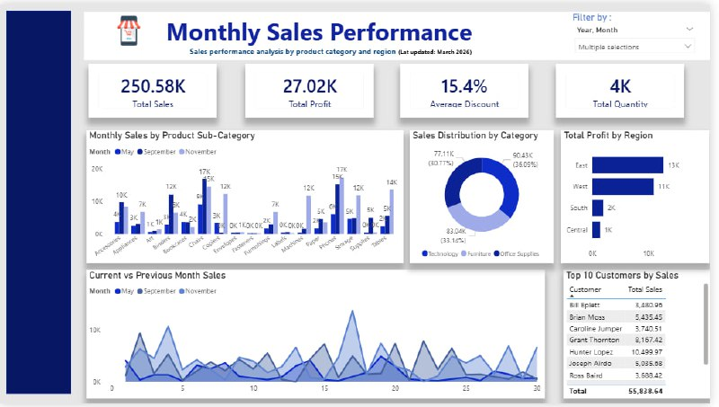
The dashboard can be accessed using the following link: https://uirabat-my.sharepoint.com/:u:/g/personal/hafsa_idsaid_uir_ac_ma/IQDdvMADg2KyS6mrebDcyXUbAadhckARapQVDMMBsKx14m8?e=Oh8nsJ

The dashboard is designed as a single-screen strategic management tool titled “Sales Dashboard – Monthly.” Its main purpose is to provide a clear and structured overview of the company’s sales performance and profitability.
At the top of the dashboard, four Key Performance Indicators (KPIs) are displayed:
- Total Sales
- Total Profit
- Average Discount
- Total Quantity
These KPIs allow management to quickly understand the overall financial performance of the company without going into detailed reports.
Below the KPIs, several visualizations provide deeper insights:
- A bar chart showing Sales by Sub-Category, which helps identify the best and worst performing products.
- A donut chart displaying Sales by Category, allowing quick comparison between Furniture, Office Supplies, and Technology.
- A bar chart presenting Profit by Region, which highlights regional performance differences.
- A line chart illustrating Sales trends over time, helping management detect growth patterns or seasonal fluctuations.
- A table showing the Top 10 Customers based on Total Sales.
The Top 10 customer table is designed to focus only on the most valuable customers. This helps management identify key revenue contributors and develop customer retention strategies without overwhelming the dashboard with too much information.
The dashboard also includes interactive filters such as Year and Month, allowing users to analyze performance across different time periods. These filters enhance the dashboard’s interactivity and flexibility.
The layout was carefully structured to ensure clarity and simplicity. KPIs are placed at the top for quick visibility, while charts are organized below to provide detailed analysis. This design makes the dashboard easy to read and supports efficient decision-making.

Dashboard Alarms
The dashboard can trigger alerts when certain metrics reach critical levels.
Examples include:
- If profit becomes negative in a region, management should investigate pricing or operational issues.
- If the average discount exceeds 30%, this may indicate aggressive pricing strategies that reduce profitability.
- If sales drop significantly compared to the previous period, managers should analyze market conditions or product performance.

Dashboard Peer Review

Reviewer: Hafsa ID SAID, Noor Muhammad
Dashboard being reviewed: Gym Data BI Dashboard
Dashboard being reviewed, created by: Azhar Shah

1: Summary & First Impressions (The "What")
This dashboard is designed to analyze gym member activity and optimize gym programs using insights from member data. It focuses on key metrics such as participation rates, workout frequency, engagement levels, and workout preferences. The primary user appears to be a gym manager or fitness business analyst aiming to improve member retention and program effectiveness.
The dashboard is visually appealing at first glance, with a clear title and structured layout. The use of KPI cards at the top immediately highlights key metrics. However, the background design slightly reduces clarity and makes the dashboard feel somewhat crowded.

2: Analysis of Strengths ("What Works")
1. Strong KPI Overview
The top section effectively presents key metrics such as total members (973), average weekly workout frequency (3.32), and high engagement rate (79.8%). This allows users to quickly assess overall performance without needing to explore deeper.
2. Logical Information Flow
The dashboard follows a clear structure:
- Overview KPIs at the top
- Distribution and behavior charts in the middle
- Detailed performance visuals at the bottom
This logical progression supports intuitive data exploration.
3. Variety of Visualizations
The use of bar charts, donut charts, and pie charts provides multiple perspectives on the data (e.g., workout types, calories burned, duration). This enhances analytical depth and user engagement.

3: Constructive Critique & Recommendations ("What Could Be Improved")

A. Clarity & Usability
The background image and overlay reduce readability of charts and text. Some labels and values are harder to read due to low contrast.
Suggestion:
- Replace the background image with a plain or lightly shaded background
- Increase contrast between text and background
- Use solid containers/cards for visuals to improve clarity

B. Strategic Relevance
While the dashboard shows useful metrics, it does not clearly highlight actionable insights (e.g., what needs improvement).
Suggestion:
- Add indicators such as arrows, colors, or icons to show trends (↑ ↓)
- Highlight critical insights like “Intermediate members dominate (406)” or “Strength is most popular”
- Include targets or benchmarks for comparison

C. Data Storytelling & Context
The dashboard includes a descriptive text box, which is good, but it feels static and not directly tied to the visuals.
Suggestion:
- Add dynamic insights (e.g., “Most members train 3 times per week”)
- Use titles that explain insights instead of just labels (e.g., “Intermediate Members Lead Participation”)
- Consider adding a summary section with key takeaways

D. Visual Design
There are inconsistencies in color usage and some visual clutter:
- Multiple colors are used without a clear meaning
- Charts feel slightly cramped
- Pie/donut charts may not be the most effective for comparison
Suggestion:
- Use a consistent color palette (e.g., one color per category across all visuals)
- Replace some pie charts with bar charts for better comparison
- Increase spacing between visuals for a cleaner layout

Overall Evaluation
This is a well-structured and insightful dashboard with strong foundational elements, particularly in KPI presentation and data variety. However, improvements in visual clarity, storytelling, and strategic emphasis would significantly enhance its effectiveness as a decision-making tool.

